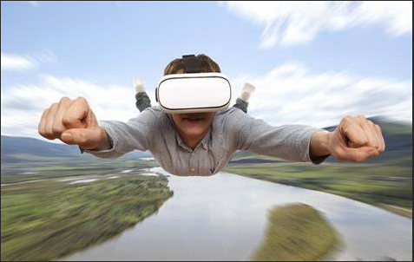**What is VR (Virtual Reality)?**

Virtual-Reality as "an artificial environment which is experienced through sensory stimuli (as sights and sounds) provided by a computer and in which one's actions partially determine what happens in the environment."

(I.e. [video games](https://en.wikipedia.org/wiki/Video_game)) and educational purposes (i.e. medical or military training). Other, distinct types of VR style technology include [augmented reality](https://en.wikipedia.org/wiki/Augmented_reality) and [mixed reality](https://en.wikipedia.org/wiki/Mixed_reality), sometimes referred to as [extended reality](https://en.wikipedia.org/wiki/Extended_reality) or XR.

Currently standard virtual reality systems use either [virtual reality headsets](https://en.wikipedia.org/wiki/Virtual_reality_headset) or multi-projected environments to generate realistic images, sounds and other sensations that simulate a user's physical presence in a virtual environment.

A person using virtual reality equipment is able to look around the artificial world, move around in it, and interact with virtual features or items. The effect is commonly created by VR headsets consisting of a [head-mounted display](https://en.wikipedia.org/wiki/Head-mounted_display) with a small screen in front of the eyes, but can also be created through specially designed rooms with multiple large screens.

Virtual reality typically incorporates [auditory](https://en.wikipedia.org/wiki/Auditory_feedback) and [video feedback](https://en.wikipedia.org/wiki/Video_feedback), but may also allow other types of sensory and force feedback through [haptic technology](https://en.wikipedia.org/wiki/Haptic_technology).

Difference between VR and AR?

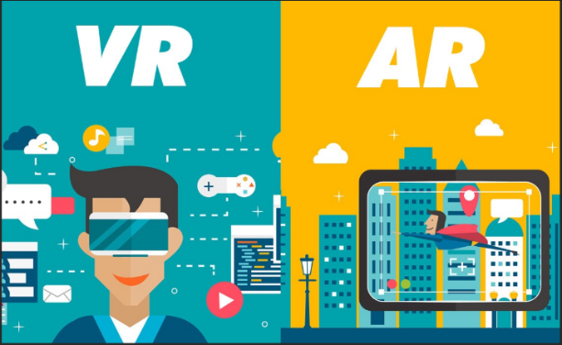Virtual reality and augmented reality accomplish two very different things in two very different ways, despite the similar designs of the devices themselves. VR replaces reality, taking you somewhere else. AR adds to reality, projecting information on top of what you're already seeing. They're both powerful technologies that have yet to make their mark with consumers, but show a lot of promise. They can completely change how we use computers in the future, but whether one or both will succeed is anyone's guess right now.

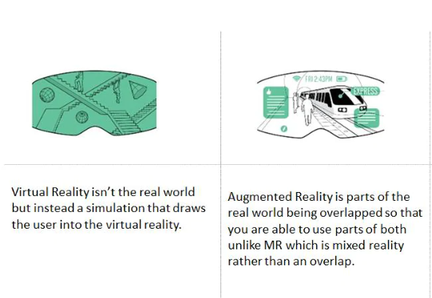

**Which is the best platform for VR?**

Virtual reality is epic to the serious gamer. You can step inside the game and often manipulate your surroundings. Placing a VR headset on is stepping into another world, and your game world will be as real as your non-game world.

Choosing the best headset for you depends on several factors. In this review, we discuss which headsets are the most affordable, easiest to use, and perfect for your level of gaming. This is the reality of the virtual experience.

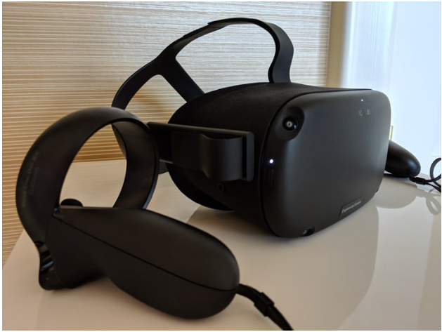[Oculus Quest](https://www.digitaltrends.com/vr-headset-reviews/oculus-quest-review/) **headset is the best platform for VR**

One of the biggest hurdles for virtual reality adoption is the ease of use. The Oculus Quest solves almost all of the problems that previously discouraged potential VR explorers. It doesn’t require any exterior sensors. It includes motion controllers, all the onboard processing it needs, and a full six-degree freedom-of-movement. Best of all, there are no wires tethering you to a PC. And best experience to play with Oculus Quest headset